Syllabus:

1. Cloud Services and Cloud Models
   1. Introduction to Cloud

Cloud Computing vs. Cluster Computing vs. Grid Computing

* 1. Introduction to Cloud Service Models
  2. Characteristics, Advantages, Security

XAAS- Anything as a Service – Storage as a service, Network as a Service, Database as a Service etc.

IAAS, PAAS, SAAS characteristics, benefits and Applications

* 1. Comparison of SAAS, PASS and IAAS
  2. Cloud Deployment Models-Public, Private, Hybrid
     1. Cloud Platforms :Google Cloud Platform, Microsoft Azure, SalesForce, AWS.
     2. **Extra Reading**: Offerings of AWS

**Introduction**

The impact of cloud computing on industry and end users would be difficult to overstate: many aspects of everyday life have been transformed by the omnipresence of software that runs on cloud networks. By leveraging cloud computing, startups and businesses are able to optimize costs and increase their offerings without purchasing and managing all the hardware and software. Independent developers are empowered to launch globally-available apps and online services. Researchers can share and analyze data at scales once reserved only for highly-funded projects. And internet users can quickly access software and storage to create, share, and store digital media in quantities that extend far beyond the computing capacity of their personal devices.

Despite the growing presence of cloud computing, its details remain obscure to many. What exactly is the cloud, how does one use it, and what are its benefits for businesses, developers, researchers, government, healthcare practitioners, and students?

**What is Cloud Computing?**

Cloud computing is the delivery of computing resources *as a service*, meaning that the resources are owned and managed by the cloud provider rather than the end user. Those resources may include anything from browser-based software applications (such as Tik Tok or Netflix), third party data storage for photos and other digital media (such as iCloud or Dropbox), or third-party servers used to support the computing infrastructure of a business, research, or personal project.

Before the broad proliferation of cloud computing, businesses and general computer users typically had to buy and maintain the software and hardware that they wished to use. With the growing availability of cloud-based applications, storage, services, and machines, businesses and consumers now have access to a wealth of on-demand computing resources as internet-accessed services. Shifting from on-premise software and hardware to networked remote and distributed resources means cloud users no longer have to invest the labor, capital, or expertise required for buying and maintaining these computing resources themselves. This unprecedented access to computing resources has given rise to a new wave of cloud-based businesses, changed IT practices across industries, and transformed many everyday computer-assisted practices. With the cloud, individuals can now work with colleagues over video meetings and other collaborative platforms, access entertainment and educational content on demand, communicate with household appliances, hail a cab with a mobile device, and rent a vacation room in someone’s house.

**Defining Cloud Computing**

The [National Institute of Standards and Technology](https://csrc.nist.gov/publications/detail/sp/800-145/final) (NIST), a non-regulatory agency of the United States Department of Commerce with a mission to advance innovation, defines cloud computing as:

a model for enabling ubiquitous, convenient, on-demand network access to a shared pool of configurable computing resources (e.g., networks, servers, storage, applications, and services) that can be rapidly provisioned and released with minimal management effort or service provider interaction.

NIST lists the following as the five essential characteristics of cloud computing:

* **On-demand self-service**: Cloud resources can be accessed or provisioned without human interaction. With this model, consumers can gain immediate access to cloud services upon signup. Organizations can also create mechanisms for allowing employees, customers, or partners to access internal cloud services on demand according to predetermined logics without needing to go through IT services.
* **Broad network access**: Users can access cloud services and resources through any device and in any networked location provided that they have permission.
* **Resource pooling**: Cloud provider resources are shared by multiple tenants while keeping the data of individual clients hidden from other clients.
* **Rapid elasticity**: Unlike on-premise hardware and software, cloud computing resources can be rapidly increased, decreased, or otherwise modified based on the cloud user’s changing needs.
* **Measured service**: Usage of cloud resources is metered so that businesses and other cloud users need only pay for the resources they use in any given billing cycle.

These characteristics offer a wide variety of transformative opportunities for businesses and individuals.

**Cloud Delivery/Service Models**

Cloud resources are provided in a variety of different delivery models that offer customers different levels of support and flexibility.

**Infrastructure as a Service (IaaS)**

*IaaS* is the on-demand delivery of computing infrastructure, including operating systems, networking, storage, and other infrastructural components. Acting much like a virtual equivalent to physical servers, IaaS relieves cloud users of the need to buy and maintain physical servers while also providing the flexibility to scale and pay for resources as needed. IaaS is a popular option for businesses that wish to leverage the advantages of the cloud and have system administrators who can oversee the installation, configuration, and management of operating systems, development tools, and other underlying infrastructure that they wish to use. However, IaaS is also used by developers, researchers, and others who wish to customize the underlying infrastructure of their computing environment. Given its flexibility, IaaS can support everything from a company’s computing infrastructure to web hosting to big data analysis.

**Platform as a Service (PaaS)**

*PaaS* provides a computing platform where the underlying infrastructure (such as the operating system and other software) is installed, configured, and maintained by the provider, allowing users to focus their efforts on developing and deploying apps in a tested and standardized environment. PaaS is commonly used by software developers and developer teams as it cuts down on the complexity of setting up and maintaining computer infrastructure, while also supporting collaboration among distributed teams. PaaS can be a good choice for developers who don’t have the need to customize their underlying infrastructure, or those who want to focus their attention on development rather than DevOps and system administration.

**Software as a Service (SaaS)**

*SaaS* providers are cloud-based applications that users access on demand from the internet without needing to install or maintain the software. Examples include GitHub, Google Docs, Slack, and Adobe Creative Cloud. SaaS applications are popular among businesses and general users given that they’re often easy to adopt, accessible from any device, and have free, premium, and enterprise versions of their applications. Like PaaS, SaaS abstracts away the underlying infrastructure of the software application so that users are only exposed to the interface they interact with.

**Cloud Environments**

Cloud services are available as public or private resources, each of which serves different needs.

**Public Cloud**

The *public cloud* refers to cloud services (such as virtual machines, storage, or applications) offered publicly by a commercial provider to businesses and individuals. Public cloud resources are hosted on the commercial provider’s hardware, which users access through the internet. They are not always suitable for organizations in highly-regulated industries, such as healthcare or finance, as public cloud environments may not comply with industry regulations regarding customer data.

**Private Cloud**

The *private cloud* refers to cloud services that are owned and managed by the organization that uses them and available only to the organization’s employees and customers. Private clouds allow organizations to exert greater control over their computing environment and their stored data, which can be necessary for organizations in highly-regulated industries. Private clouds are sometimes seen as more secure than public clouds as they are accessed through private networks and enable the organization to directly oversee their cloud security. Public cloud providers sometimes provide their services as applications that can be installed on private clouds, allowing organizations to keep their infrastructure and data on premise while taking advantage of the public cloud’s latest innovations.

**Hybrid Cloud and Multicloud**

Many organizations use a *hybrid cloud* environment which combines public and private cloud resources to support the organization’s computing needs while maintaining compliance with industry regulation. *Multicloud* environments are also common, which entail the use of more than one public cloud provider (for example, combining Amazon Web Services and DigitalOcean).

**Benefits of Cloud Computing**

Cloud computing offers a variety of benefits to individuals, businesses, developers, and other organizations. These benefits vary according to the cloud users goals and activities.

**For Business and Industry**

Prior to the proliferation of cloud computing, most businesses and organizations needed to purchase and maintain the software and hardware that supported their computing activities. As cloud computing resources became available, many businesses began using them to store data, provide enterprise software, and deploy online products and services. Some of these cloud-based adoptions and innovations are industry-specific. In healthcare, many providers use cloud services that are specifically designed to store and share patient data or communicate with patients. In academia, educators and researchers use cloud-based teaching and research apps. But there are also a large number of general cloud-based tools that have been adopted across industries, such as apps for productivity, messaging, expense management, video conferencing, project management, newsletters, surveys, customer relations management, identity management, and scheduling. The rapid growth of cloud-based business apps and infrastructure shows that the cloud isn’t just changing business IT strategy: it’s a booming business in its own right.

Cloud-based technologies offer businesses several key advantages. First, they can help optimize IT costs. As businesses shift towards renting computing resources, they no longer have to invest as much in purchasing and maintaining on-premise IT infrastructure. Cloud computing is also enormously flexible, allowing businesses to rapidly scale (and only pay for) the computing resources they actually use. Cost, however, is not the only consideration that drives cloud adoption in business. Cloud-based technologies can help make internal IT processes more efficient as they can be accessed on demand by employees without needing to go through IT approval processes. Cloud-based apps can improve collaboration across a business as they allow for real-time communication and data sharing.

**For Independent Developers**

Computing resources that were once only affordable to large companies and organizations are now available on demand through an internet connection and at a fraction of their previous cost. In effect, independent developers can rapidly deploy and experiment with cloud-based apps. Cloud-based apps for sharing code (such as GitHub) have also made it easier for developers to build upon and collaborate on open source software projects. Additionally, cloud-based educational platforms and interactive coding tutorials have expanded access to developer education, enabling individuals without formal technical training to learn to code in their own time.

Altogether, these cloud-based computing and educational resources have helped lower the barriers to learning developer skills and deploying cloud-based apps. Formal training, company support, and massive amounts of startup capital are no longer necessary for individuals to experiment with creating and deploying apps, allowing for more individuals to participate in cloud development, compete with established industry players, and create and share apps as side projects.

**For Researchers**

As [machine learning](https://www.digitalocean.com/community/tutorials/an-introduction-to-machine-learning) methods become increasingly important in scientific research, cloud computing has become essential to many scientific fields, including astronomy, physics, genomics, and artificial intelligence. The massive amount of data collected and analyzed in machine learning and other data-intensive research projects often require computing resources that scale beyond the capacity of hardware owned by an individual researcher or provisioned by the university. Cloud computing allows researchers to access (and only pay for) computing resources as their workloads require and allows for real-time collaboration with research partners across the globe. Without commercial cloud providers, a majority of academic machine learning research would be limited to individuals with access to university-provisioned, high-powered computing resources.

**For Educators and Students**

Cloud computing has also provided students with tools for supplementing their education and opportunities to put their technical skills into practice as they learn. Cloud-based apps for sharing, teaching, and collaborating on code and data (such as [GitHub](https://www.digitalocean.com/community/meetup_kits/hacktoberfest-workshop-kit-how-to-submit-your-first-pull-request-on-github) and [Jupyter Notebooks](https://www.digitalocean.com/community/tutorials/how-to-set-up-jupyter-notebook-for-python-3)) enable students to learn technical skills in a hands-on manner by studying, deploying, and contributing to open source software and research projects relevant to their field or professional aspirations. And just like independent developers, students are able to use cloud computing resources to share their code and apps with the public and reap the satisfaction of understanding the real-world application of their skills.

Students, researchers, and educators can also take advantage of cloud computing resources to support personalized academic infrastructure and practice greater control over their computing environments. Some academics prefer this approach as it lets them pick which applications they use, customize the functionality and design of these tools, and limit or prohibit the collection of data. There are also a growing number of cloud-based applications developed specifically for academic purposes that supplement or provide alternatives to traditional academic IT offerings. [Voyant Tools](https://voyant-tools.org/) offers students and researchers a code-free method for providing textual analysis on documents of their choosing and [The HathiTrust](https://www.hathitrust.org/) provides access to its digital collection of millions of volumes. [Reclaim Hosting](https://reclaimhosting.com/), [Commons in a Box](https://commonsinabox.org/), the [Modern Language Humanities Commons](https://hcommons.org/), and [Manifold](https://manifoldapp.org/) offer educational, publishing, and networking tools designed specifically for academic communities.

**For Community Infrastructure**

Some individuals and communities choose to install and manage their own cloud-based software to serve community needs and values, customize functionality, protect user data, and have more control over their computing environment. Open source software, such as social media tools like [Mastodon](https://joinmastodon.org/), video conferencing software like [Jitsi](https://www.digitalocean.com/community/tutorials/how-to-install-jitsi-meet-on-ubuntu-20-04), collaborative text editors like [Etherpad](https://etherpad.org/), and web chat tools like [Rocket Chat](https://www.digitalocean.com/community/tutorials/how-to-install-configure-and-deploy-rocket-chat-on-ubuntu-14-04), provide alternatives to SaaS platforms that often limit user’s control, privacy, and oversight over their computing environment. While often requiring more administrative work than SaaS applications or social media platforms, some communities prefer these options given ethical concerns about the use of personal data and company practices with popular platforms and SaaS applications.

**Benefits of cloud computing:**

* On-demand self-service: A client can provision computer resources without the need for interaction with cloud service provider personnel.
* Broad network access: Access to resources in the cloud is available over the network using standard methods in a manner that provides platform-independent access to clients of all types.
* Resource pooling: A cloud service provider creates resources that are pooled together in a system that supports multitenant usage. Physical and virtual systems are dynamically allocated or reallocated as needed
* Rapid elasticity: Resources can be rapidly and elastically provisioned. scaling up systems (more powerful computers) or scaling out systems (more computers of the same kind). Scaling may be automatic or  
  manual.
* Measured service: The use of cloud system resources is measured, audited, and reported to the customer based on a metered system.
* **Lower costs:** Because cloud networks operate at higher efficiencies and with greater utilization, significant cost reductions are often encountered.
* **Ease of utilization:** do not require hardware or software licenses to implement your service.
* **Quality of Service:** obtain QoS under contract from your vendor.
* **Reliability:** The scale of cloud computing networks and their ability to provide load balancing and failover makes them highly reliable,
* **Outsourced IT management:** A cloud computing deployment lets someone else manage your computing infrastructure while you manage your business
* **Simplified maintenance and upgrade:** Because the system is centralized, you can easily apply patches and upgrades. This means your users always have access to the latest software versions.
* **Low Barrier to Entry:** In particular, upfront capital expenditures are dramatically reduced. In cloud computing, anyone can be a giant at any time.

**Risks, Costs, and Ethics in Cloud Computing**

Though the cloud offers many benefits, it also comes with its own set of risks, costs, and ethical questions that should be considered. Some of these issues are relevant to all cloud users, while others are more applicable to businesses and organizations that use the cloud to store customers’ data:

**Considerations for all cloud users:**

* **Security**: Cloud resources can have additional security vulnerabilities (compared to traditional on-premise data centers) given their use of APIs, cloud-based credentials, and on-demand services that make it easier for attackers to obtain unauthorized access. Find out what measures the cloud service provider takes to secure customer data from theft and other attacks and what practices or additional services customers can implement to safeguard their data.
* **Data loss**: Just as with physically-owned or managed devices, cloud services can permanently lose stored data due to physical disasters, bugs, unintended syncing, user-generated errors, or other unforeseen issues. When implementing cloud services, find out what backup services the provider offers and be aware that these may not be automatically or freely provided. You may also choose to run backups yourself.
* **Data persistence**: There are times when cloud users may want to ensure the deletion of personal data they’ve given to cloud service providers. However, the processes for deleting data on cloud resources and verifying that deletion can be time-consuming, complicated, or even impossible. Before you give cloud providers access to your data, find out what their policies are for deleting it in case you want to remove the data later.
* **Costs**: Though the cloud can provide computing services at a fraction of the cost of owning them, expenses for cloud services can quickly ramp up with usage. When signing up for a cloud service, check the billing details to learn how services are metered and whether you can set caps or notifications when usage goes beyond your desired limits. It is also worth researching how billing details are communicated, as the billing methods of some providers are not always easy to understand.
* **Vendor lock-in**: Users of proprietary cloud services may be at more risk for vendor lock in, or the condition in which it becomes difficult or impossible to change providers once computing operations are structured to fit a closed, proprietary system. Using open source cloud solutions can help alleviate this risk as its open standards make it easier to migrate computing operations from one provider to another. However, cloud users should be aware that any migration will take work, planning, and expertise.
* **Company use of data**: Cloud service providers may use data to understand customer use of their product, sell or personalize ads, train machine learning algorithms, or even sell customer data to outside entities. If you have concerns about how your or your organization’s data is used, make sure to find out the service provider’s policies regarding their use of it.
* **Company ethic**: Given the vast power some cloud service providers have over world affairs, cloud users may want to consider the ethics of the company that their business is supporting. Reviewing company practices with regard to topics such as data collection, advertising, hate speech, politics, misinformation, the environment, and labor may help a cloud user choose a provider that best reflects their personal values.
* **Loss of user control and visibility**: The use of third-party computing resources makes it difficult or impossible for cloud users to have full visibility and control over their computing environments, which can create a variety of technical and trust concerns. Some of these technical concerns can be helped through the use of monitoring and analytics tools which allow cloud users to stay updated on their infrastructure’s performance, allowing users to respond quickly when problems arise. Trust concerns — such as those related to a company’s use of personal data — can be addressed by reviewing the company’s customer data policies and public forms of analysis about its data practices.

Advantages of cloud computing

* **Cost:** It reduces the huge capital costs of buying hardware and software.
* **Speed:** Resources can be accessed in minutes, typically within a few clicks.
* **Scalability:**We can increase or decrease the requirement of resources according to the business requirements.
* **Productivity:**While using cloud computing, we put less operational effort. We do not need to apply patching, as well as no need to maintain hardware and software. So, in this way, the IT team can be more productive and focus on achieving business goals.
* **Reliability:**Backup and recovery of data are less expensive and very fast for business continuity.
* **Security:**Many cloud vendors offer a broad set of policies, technologies, and controls that strengthen our data security.

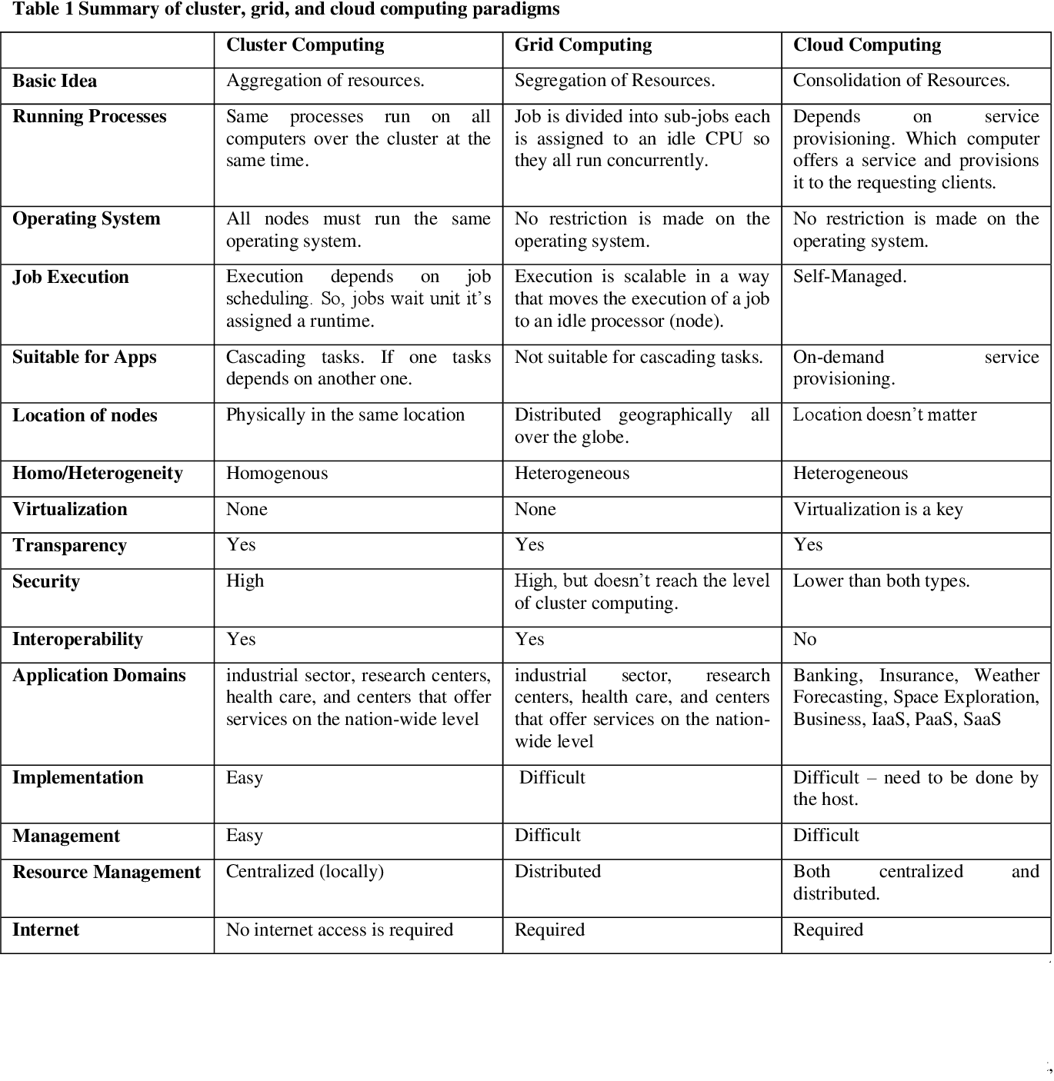

Cloud Computing Security

**Security** in cloud computing is a major concern. Data in cloud should be stored in encrypted form. To restrict client from accessing the shared data directly, proxy and brokerage services should be employed.

Security Planning

Before deploying a particular resource to cloud, one should need to analyze several aspects of the resource such as:

* Select resource that needs to move to the cloud and analyze its sensitivity to risk.
* Consider cloud service models such as **IaaS, PaaS,** and **SaaS.** These models require customer to be responsible for security at different levels of service.
* Consider the cloud type to be used such as **public, private, community** or **hybrid.**
* Understand the cloud service provider's system about data storage and its transfer into and out of the cloud.
* The risk in cloud deployment mainly depends upon the service models and cloud types.
* Understanding Security of Cloud
* Security Boundaries
* A particular service model defines the boundary between the responsibilities of service provider and customer. **Cloud Security Alliance (CSA)** stack model defines the boundaries between each service model and shows how different functional units relate to each other.

**Advantages of IaaS**

* The resources can be deployed by the provider to a customer’s environment at any given time.
* Its ability to offer the users to scale the business based on their requirements.
* The provider has various options when deploying resources including virtual machines, applications, storage, and networks.
* It’s potential to handle an immense number of users.
* It is easy to expand and saves a lot of money. Companies can afford the huge costs associated with the implementation of advanced technologies.

**Advantages of PaaS –**

* Programmers need not worry about what specific database or language the application has been programmed in.
* It offers developers to build applications without the overhead of the underlying operating system or infrastructure.
* Provides the freedom to developers to focus on the application’s design while the platform takes care of the language and the database.

**Advantages of SaaS**

* It is a cloud computing service category providing a wide range of hosted capabilities and services. These can be used to build and deploy web-based software applications.
* It provides a lower cost of ownership than on-premises software. The reason is it does not require the purchase or installation of hardware or licenses.
* It can be easily accessed through a browser along a thing client.

**What is IaaS?**

Infrastructure as a Service (IaaS) is a business service model that delivers computer infrastructure technology on an outsourced, rental basis to support "virtual data center" operations. Typically, IaaS provides hardware, storage, servers and data center space or network components; it may also include software.

An IaaS provider provides policy-based services and is responsible for housing, operating and maintaining the infrastructure equipment it provides for a client. Clients usually pay on a per-use or utility computing basis.

Characteristics of IaaS systems include:

* Automated administrative tasks
* Dynamic scaling
* Platform virtualization technology
* GUI and API-based access
* Internet connectivity

IaaS is also described as one of three main categories of cloud computing service. The other two are software as a service (SaaS) and platform as a service (PaaS).

**Characteristics of IaaS, PaaS and SaaS**

**IaaS Characteristics**

* Scale
* Converged network and IT capacity pool
* Self-service and on-demand capacity
* High reliability and resilience

**IaaS key Benefits**

* Usage is metered and price on the basis of units (or instances) consumed
* The ability to scale up and down of infrastructure service based on actual usage.
* Reduced cost of ownership
* Reduced energy and cooling costs.

**PaaS Key Characteristics**

* Support multiple languages and frameworks
* Multiple hosted environments
* Flexibility
* Allow choice and reduce “lock-in”
* Ability to “Auto-scale”

**PaaS Key Benefits**

* The operating system can be changed and upgraded frequently including associated features and systems services
* Globally distributed development teams are able to work together on software development projects within the same environment
* Service is available and can be obtained from diverse sources that cross international boundaries.
* Upfront and recurring or ongoing costs can be significantly reduced.

**Software as a Service (SaaS)**

SaaS

* SaaS is a distributed model where the software application is hosted by a vendor or cloud service provider and made available to customers over network resources
* Two delivery models:

1. “Hosted Application Management” (hosted AM)
2. “Software on Demand”

**Application**

* Clients are able to access their application and data from anywhere at any time
* Overall reduction of costs
* Application and Software Licensing
* Reduced Support Costs
* Back End Systems and Capabilities

**SaaS Benefits**

* Ease of use and limited/minimal administration
* Automatic updates and patch management
* Standardization and compatibility
* Global accessibility

**Comparison of SAAS, PAAS and IAAS:**

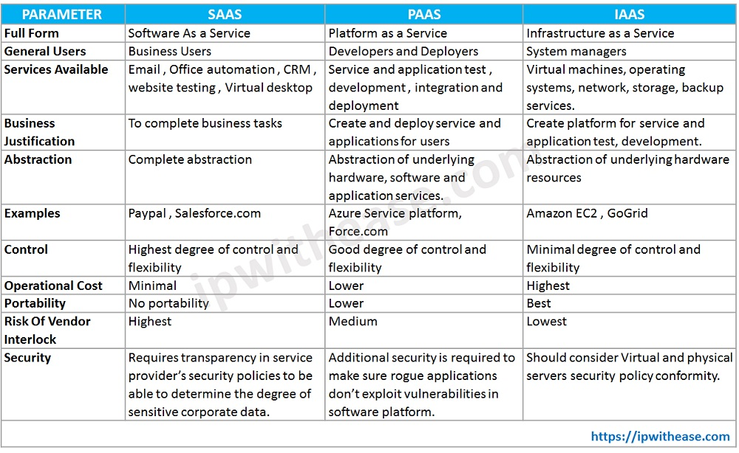

Xaas in Cloud Computing

"**Anything as a service**" (XaaS) describes a general category of cloud computing and remote access services. It recognizes the vast number of products, tools, and technologies now delivered to users as a service over the Internet.

Essentially, any IT function can be a service for enterprise consumption. **The service is paid for in a flexible consumption model rather than an advance purchase or license.**

What are the benefits of XaaS?

XaaS has many benefits: improving spending models, speeding up new apps and business processes, and shifting IT resources to high-value projects.

* **Expenditure model improvements.** With XaaS, businesses can cut costs by purchasing services from providers on a subscription basis. Before XaaS and cloud services, businesses had to buy separate products-software, hardware, servers, security, infrastructure-install them on-site, and then link everything together to form a network. With XaaS, businesses buy what they need and pay on the go. The previous capital expenditure now becomes an operating expense.
* **Speed up new apps and business processes.** This model allows businesses to adopt new apps or solutions to changing market conditions. Using multi-tenant approaches, cloud services can provide much-needed flexibility. Resource pooling and rapid elasticity support mean that business leaders can add or subtract services. When users need innovative resources, a company can use new technologies, automatically scaling up the infrastructure.
* **Transferring IT resources to high-value projects.** Increasingly, IT organizations are turning to a XaaS delivery model to streamline operations and free up resources for innovation. They are also harnessing the benefits of XaaS to transform digitally and become more agile. XaaS gives more users access to cutting-edge technology, democratizing innovation. In a recent survey by Deloitte, 71% of companies report that XaaS now constitutes more than half of their company's enterprise IT.

These characteristics include:

* Catalog-based, on-demand service delivery
* Automated scalability and service elasticity
* Multitenancy with shared resource pools
* Metering with utility-style operating expense models
* Software-defined, centrally managed infrastructure
* Self-service lifecycle management of services

**Storage as a service (STaaS):**

Storage as a service (STaaS) is a managed service in which the provider supplies the customer with access to a data storage platform. The service can be [delivered on premises](https://www.techtarget.com/searchstorage/feature/On-premises-STaaS-shifts-storage-buying-to-Opex-model) from infrastructure that is dedicated to a single customer, or it can be delivered from the public cloud as a shared service that's purchased by subscription and is billed according to one or more usage metrics.

STaaS customers access individual storage services through standard system interface protocols or application program interfaces ([APIs](https://www.techtarget.com/searchapparchitecture/definition/application-program-interface-API)). Typical offerings include bare-metal storage capacity; raw storage volumes; network file systems; storage objects; and storage applications that support file sharing and [backup](https://www.techtarget.com/searchdatabackup/definition/backup) lifecycle management.

Storage as a service was originally seen as a cost-effective way for small and mid-size businesses that lacked the technical personnel and capital budget to implement and maintain their own storage infrastructure. Today, companies of all sizes use storage as a service.

**Uses of STaaS**

Storage as a service can be used for **data transfers and redundant storage, as well as to restore any corrupted or lost data**. As an example, instead of maintaining a large tape library and arranging to vault (store) tapes off site, a network administrator that uses STaaS for backups could specify what data on the network should be backed up and how often it should be backed up. Their company would sign a service-level agreement ([SLA](https://www.techtarget.com/searchitchannel/definition/service-level-agreement)) whereby the STaaS provider agrees to rent storage space on a cost-per-gigabyte-stored and cost-per-data-transfer basis, and the company's data would then be automatically transferred at the specified time over the storage provider's proprietary wide area network ([WAN](https://www.techtarget.com/searchnetworking/definition/WAN-wide-area-network)) or the internet. If the company's data were to ever become corrupt or get lost, the network administrator could contact the STaaS provider and request a copy of the data.

**Storage as a service in cloud computing**

Instead of storing data on-premises, organizations that use STaaS will typically utilize a [public cloud](https://www.techtarget.com/searchcloudcomputing/definition/public-cloud) for storage and backup needs. Public cloud storage may also use different storage methods for STaaS. These storage methods include backup and restore, disaster recovery, block storage, SSD storage, object storage and bulk data transfer. Backup and restore refers to the backing up of data to the cloud, which provides protection in case of data loss. Disaster recovery may refer to protecting and replicating data from virtual machines ([VMs](https://searchservervirtualization.techtarget.com/definition/virtual-machine)).

[Block storage](https://www.techtarget.com/searchstorage/definition/block-storage) enables customers to provision block storage volumes for lower-latency [I/O](https://www.techtarget.com/whatis/definition/input-output-I-O).

SSD(Solid state drivers) storage is another storage type that is typically used for intensive read/write and I/O operations.

Object storage systems are used in data analytics, disaster recovery and cloud applications and tend to have high latency.

Cold storage is used to create and configure stored data quickly. Bulk data transfers will use disks and other hardware to transfer data.

**Advantages of STaaS**

Key advantages to STaaS in the enterprise include the following:

* **Storage costs.** Personnel, hardware and physical storage space expenses are reduced.
* **Disaster recovery.** Having multiple copies of data stored in different locations can better enable disaster recovery measures.
* **Scalability.**With most public cloud services, users only pay for the resources that they use.
* **Syncing.** Files can be automatically synced across multiple devices.
* **Security.**Security can be both an advantage and a disadvantage, as security methods may change per vendor. Data tends to be encrypted during transmission and while at rest.

**What is Network as a Service (NaaS)?**

The network as a service provides networking infrastructure to the customers, who don’t want to build their own application. The third party can deliver the network infrastructure.

NaaS includes services such as Wide Area Networking Connectivity, Data center Connectivity, Bandwidth on Demand, and other applications. It includes the optimization of resource allocations by making network and computing resources as a unified whole.

Here, the product can be purchased for multiple users, for a particular time period. We can use NaaS with other marketing items such as **cloud computing**. NaaS sometimes includes network **virtualization** using a protocol that is OpenFlow.

Features of Network as a Service

Let’s discuss some NaaS **Features in Cloud Computing**:

* NaaS allows the customer to access the internet directly and in a secure manner. In addition, it allows the customer to run custom routing protocols.
* With the help of a virtualized network, the NaaS provides network service to the consumer. This feature benefits the customer as they don’t have to manage and worry about the infrastructure and can focus on developing the business.
* It helps the user in a way by providing them with a virtual environment which saves their physical costs such as the cost of the hardware and their maintenance.
* Also, it has a feature of remote access through which a customer can access the data from anywhere and at any time with the help of internet connection.

Benefits of Network as a Service

Following are some advantages of NaaS:

* A network as a Service minimizes the time taken by the staff to maintain and for the commitment and due to this, the business grows.
* NaaS also has a guaranteed uptime to a location. This benefits the customers and is one of the primary business concerns.
* SD-WAN technologies are available at NaaS, which provides an easy to use multiple network links that helps in connectivity.
* SD-Wan technology also helps to solve the issues related to traffic engineering for applications such as VoIP.
* There is an ease with deployment and management at the NaaS model with the help of SD-WAN.

**Requirements of NaaS**

One of the major requirements is the integration with current DC(Domain Controller)  **hardware** as the existing constitutes a significant investment. Use of commodity networking equipment reduces the cost of large DC deployments.

Another requirement is, Network as a Service should expose a natural programming model, which should be the high-level model. Moreover, it should not expose the full complexity of physical network topology in the DC.

The third requirement is that NaaS should support the multitude of different applications, running concurrently unaware of each other. This whole thing is called scalability and multi-tenancy isolation.

**Database as a Service (DBaaS) :**  
Like[SaaS, PaaS and IaaS](https://www.geeksforgeeks.org/cloud-based-services/)of cloud computing we can consider DBaaS (also known as Managed Database Service) as a cloud computing service. It allows users associated with database activities to access and use a cloud database system without purchasing it.

DBaaS and cloud database comes under Software as a Service (SaaS) whose demand is growing so fast  
In simple we can say Database as a Service (DBaaS) is self service/ on demand database consumption coupled with automation of operations. As we know cloud computing services are like pay per use so DBaaS also based on same payment structure like how much you will use just pay for your usage. This DBaaS provides same function as like standard traditional and relational database models. So using DBaaS, organizations can avoid data base configuration, management, upgradation and security.

DBaaS consists of an info manager element, that controls all underlying info instances via API. This API is accessible to the user through a management console, typically an online application, that the user might use to manage and assemble the info and even provision or deprovision info instances.

**Key Characteristics of DBaaS :**

* A fully managed info service helps to line up, manage, and administer your info within the cloud and conjointly offer services for hardware provisioning and Backup.
* DBaaS permits the availability of info’s effortlessly to Database shoppers from numerous backgrounds and IT expertise.
* Provides on demand services.
* Supported the resources offered, it delivers a versatile info platform that tailors itself to the environment’s current desires.
* A team of consultants at your disposal, endlessly watching the Databases.
* Automates info administration and watching.
* Leverages existing servers and storage.

**How does DBaaS work ?**  
It is a service that is added to our databases which make our daily tasks easier. It eliminates tedious and time-consuming administration tasks and makes our tasks simpler and more flexible. Now most of the organizations are going for DBaaS as it helps organizations to accelerate their business performance by starting their working with database more easily and running the workloads without delay.

Once we move our database to the cloud, we have the option to add software deployment as a service. Doing so simplifies the processes required to make information available through Internet-based communications. Storage consolidation can also be useful for moving company databases to the cloud.

**Advantages of DBaaS :**

1. DBaaS is responsible of the info supplier to manage and maintain info hardware and code.
2. The hefty power bills for ventilation and cooling bills to stay the servers running area unit eliminated.
3. An organization that subscribes to DBaaS is free from hiring info developers or constructing a info system in-house.
4. Make use of the most recent automation, straightforward outs of clouds area unit possible at low price and fewer time.
5. Human resources needed to manage the upkeep of the system is eliminated.
6. Since DBaaS is hosted off-site, the organization is free from the hassles of power or network failure.
7. Explore the portfolio of Oracle info as a service.

**Google Cloud Platform** (**GCP**), offered by [Google](https://en.wikipedia.org/wiki/Google), is a suite of [cloud computing](https://en.wikipedia.org/wiki/Cloud_computing) services that runs on the same infrastructure that Google uses internally for its end-user products, such as [Google Search](https://en.wikipedia.org/wiki/Google_Search), [Gmail](https://en.wikipedia.org/wiki/Gmail), [Google Drive](https://en.wikipedia.org/wiki/Google_Drive), and [YouTube](https://en.wikipedia.org/wiki/YouTube). Alongside a set of management tools, it provides a series of modular cloud services including computing, [data storage](https://en.wikipedia.org/wiki/Computer_data_storage), [data analytics](https://en.wikipedia.org/wiki/Data_analysis) and [machine learning](https://en.wikipedia.org/wiki/Machine_learning).[[3]](https://en.wikipedia.org/wiki/Google_Cloud_Platform#cite_note-auto-3)  Google Cloud Platform provides [infrastructure as a service](https://en.wikipedia.org/wiki/Infrastructure_as_a_service), [platform as a service](https://en.wikipedia.org/wiki/Platform_as_a_service), and [serverless computing](https://en.wikipedia.org/wiki/Serverless_computing" \o "Serverless computing) environments.

In April 2008, Google announced [App Engine](https://en.wikipedia.org/wiki/Google_App_Engine), a platform for developing and hosting web applications in Google-managed [data centers](https://en.wikipedia.org/wiki/Data_center), which was the first cloud computing service from the company. The service became generally available in November 2011. Since the announcement of App Engine, Google added multiple cloud services to the platform.

Google Cloud Platform is a part[[5]](https://en.wikipedia.org/wiki/Google_Cloud_Platform#cite_note-5) of **Google Cloud**, which includes the Google Cloud Platform public cloud infrastructure, as well as [Google Workspace](https://en.wikipedia.org/wiki/Google_Workspace) (G Suite), enterprise versions of [Android](https://en.wikipedia.org/wiki/Android_(operating_system)) and [Chrome OS](https://en.wikipedia.org/wiki/Chrome_OS), and [application programming interfaces (APIs)](https://en.wikipedia.org/wiki/Application_programming_interface) for [machine learning](https://en.wikipedia.org/wiki/Machine_learning) and enterprise mapping services.

## What is Google Cloud Platform?

Google Cloud Platform (GCP) is a suite of cloud computing services provided by Google. It is a public cloud computing platform consisting of a variety of services like compute, storage, networking, application development, Big Data, and more, which run on the same cloud infrastructure that Google uses internally for its end-user products, such as Google Search, Photos, Gmail and YouTube, etc.

The services of GCP can be accessed by software developers, cloud administrators and IT professionals over the Internet or through a dedicated network connection.

## Why Google Cloud Platform?

Google Cloud Platform is known as one of the leading cloud providers in the [IT](https://www.javatpoint.com/it-full-form)

field. The services and features can be easily accessed and used by the software developers and users with little technical knowledge. Google has been on top amongst its competitors, offering the highly scalable and most reliable platform for building, testing and deploying the applications in the real-time environment.

Apart from this, GCP was announced as the leading cloud platform in the Gartner's IaaS Magic Quadrant in 2018. Gartner is one of the leading research and advisory company. Gartner organized a campaign where Google Cloud Platform was compared with other cloud providers, and GCP was selected as one of the top three providers in the market.

Most companies use data centers because of the availability of cost forecasting, hardware certainty, and advanced control. However, they lack the necessary features to run and maintain resources in the data center. GCP, on the other side, is a fully-featured cloud platform that includes:

* **Capacity**: Sufficient resources for easy scaling whenever required. Also, effective management of those resources for optimum performance.
* **Security**: Multi-level security options to protect resources, such as assets, network and OS -components.
* **Network Infrastructure**: Number of physical, logistical, and human-resource-related components, such as wiring, routers, switches, firewalls, load balancers, etc.
* **Support**: Skilled professionals for installation, maintenance, and support.
* **Bandwidth**: Suitable amount of bandwidth for peak load.
* **Facilities**: Other infrastructure components, including physical equipment and power resources.

Therefore, Google Cloud Platform is a viable option for businesses, especially when the businesses require an extensive catalog of services with global recognition.

## Benefits of Google Cloud Platform

Some of the main benefits of Google Cloud Platform are explained below:

**Best Pricing**: Google enables users to get Google Cloud hosting at the cheapest rates. The hosting plans are not only cheaper than other hosting platforms but also offer better features than others. GCP provides a pay-as-you-go option to the users where users can pay separately only for the services and resources they want to use.

**Work from Anywhere**: Once the account is configured on GCP, it can be accessed from anywhere. That means that the user can use GCP across different devices from different places. It is possible because Google provides web-based applications that allow users to have complete access to GCP.

**Private Network**: Google has its own network that enables users to have more control over GCP functions. Due to this, users achieve smooth performance and increased efficiency over the network.

**Scalable**: Users are getting a more scalable platform over the private network. Because Google uses fiber-optic cables to extend its network range, it is likely to have more scalability. Google is always working to scale its network because there can be any amount of traffic at any time.

**Security**: There is a high number of security professionals working at Google. They always keep trying to secure the network and protect the data stored on servers. Additionally, Google uses an algorithm that encrypts all the data on the Cloud platform. This gives assurance to the users that their data is completely safe and secure from unauthorized sources.

**Redundant Backup**: Google always keeps backup of user's data with built-in redundant backup integration. In case a user has lost the stored data, it's not a big problem. Google always has a copy of the users' data unless the data is deleted forcefully. This adds data integrity, reliability and durability with GCP.

## Key Features of Google Cloud Platform

The following are some key features of Google Cloud Platform:

* **On-demand services**: Automated environment with web-based tools. Therefore, no human intervention is required to access the resources.
* **Broad network access**: The resources and the information can be accessed from anywhere.
* **Resource pooling**: On-demand availability of a shared pool of computing resources to the users.
* **Rapid elasticity**: The availability of more resources whenever required.
* **Measured service**: Easy-to-pay feature enables users to pay only for consumed services.

### Security and Identity Management

GCP includes the following services related to Security and Identity management:

* **Cloud Data Loss Prevention API**: It is mainly designed to manage sensitive data. It helps users manage sensitive data elements like credit card details, debit card details, passport numbers, etc. It offers fast and scalable classification for sensitive data.
* **Cloud IAM**: It stands for Cloud Identity and Access Management. It is a framework that contains rules and policies and validates the authentication of the users for accessing the technology resources. That is why it is also known as Identity Management (IdM).

## Advantages of Google Cloud Platform

There are several advantages of using Google Cloud Platform, such as:

* **Google Cloud Offers Quick and Easy Collaboration**: Multiple users can access the data and simultaneously contribute their information. This is possible because the data is stored on the cloud servers, not on the user's personal computers.
* **Higher Productivity with Continuous Development**: Google is always working on adding new features and functionalities to provide higher productivity to the customers. Therefore, Google delivers frequent updates to its products and services.
* **Less Disruption with Adopting New Features**: Instead of pushing huge disruptive updates of changes, Google provides small updates weekly. This helps users to understand and adopt new features easily.
* **Least or Minimal Data is stored on Vulnerable Devices**: Google does not store data on local devices unless a user explicitly tries to do it. This is because the data stored on local devices may get compromised compared to the cloud's data.
* **Users can access Google Cloud from Anywhere**: The best thing is that a user can easily access the information stored on Google cloud from anywhere because it is operated through web-based applications.
* **Google provides Maximum Security with its Robust Structure**: Google hires leading security professionals to protect user's data. Users get process-based and physical security features made by Google.
* **Users have Full Control over their Data**: Users gain full control over services and the data stored in Google Cloud. If a user does not want to use Google services any longer and wants to delete the cloud data, it can be easily performed.
* **Google provides Higher Uptime and Reliability**: Google uses several resources to provide higher and reliable up-time servers. If a data center is not working for technical issues, the system will automatically communicate with the secondary center without interruption visible to users.

**What is Azure?**

Azure is Microsoft’s cloud platform, just like Google has it’s Google Cloud and Amazon has it’s Amazon Web Service or AWS.000. Generally, it is a platform through which we **can use Microsoft’s resource. For example, to set up a huge server, we will require huge investment, effort, physical space and so on.** In such situations, Microsoft Azure comes to our rescue. It will provide us with virtual machines, fast processing of data, analytical and monitoring tools and so on to make our work simpler. The pricing of Azure is also simpler and cost-effective. Popularly termed as “Pay As You Go”, which means how much you use, pay only for that.

**How Azure can help in business?**

Azure can help in our business in the following ways-

* **Capital less:**We don’t have to worry about the capital as Azure cuts out the high cost of hardware. You simply pay as you go and enjoy a subscription-based model that’s kind to your cash flow. Also, to set up an Azure account is very easy. You simply register in Azure Portal and select your required subscription and get going.
* **Less Operational Cost:**Azure has low operational cost because it runs on its own servers whose only job is to make the cloud functional and bug-free, it’s usually a whole lot more reliable than your own, on-location server.
* **Cost Effective:**If we set up a server on our own, we need to hire a tech support team to monitor them and make sure things are working fine. Also, there might be a situation where the tech support team is taking too much time to solve the issue incurred in the server. So, in this regard is way too pocket-friendly.
* **Easy Back Up and Recovery options:**Azure keep backups of all your valuable data. In disaster situations, you can recover all your data in a single click without your business getting affected. Cloud-based backup and recovery solutions save time, avoid large up-front investment and roll up third-party expertise as part of the deal.
* **Easy to implement:**It is very easy to implement your business models in Azure. With a couple of on-click activities, you are good to go. Even there are several tutorials to make you learn and deploy faster.
* **Better Security:**Azure provides more security than local servers. Be carefree about your critical data and business applications. As it stays safe in the Azure Cloud. Even, in natural disasters, where the resources can be harmed, Azure is a rescue. The cloud is always on.
* **Work from anywhere:**Azure gives you the freedom to work from anywhere and everywhere. It just requires a network connection and credentials. And with most serious Azure cloud services offering mobile apps, you’re not restricted to which device you’ve got to hand.
* **Increased collaboration:**With Azure, teams can access, edit and share documents anytime, from anywhere. They can work and achieve future goals hand in hand. Another advantage of the Azure is that it preserves records of activity and data. Timestamps are one example of the Azure’s record keeping. Timestamps improve team collaboration by establishing transparency and increasing accountability.

**Microsoft Azure Services**

Some following are the services of Microsoft Azure offers:

1. **Compute:**Includes Virtual Machines, Virtual Machine Scale Sets, Functions for serverless computing, Batch for containerized batch workloads, Service Fabric for microservices and container orchestration, and Cloud Services for building cloud-based apps and APIs.
2. **Networking:**With Azure you can use variety of networking tools, like the Virtual Network, which can connect to on-premise data centers; Load Balancer; Application Gateway; VPN Gateway; Azure DNS for domain hosting, Content Delivery Network, Traffic Manager, ExpressRoute dedicated private network fiber connections; and Network Watcher monitoring and diagnostics
3. **Storage:**Includes Blob, Queue, File and Disk Storage, as well as a Data Lake Store, Backup and Site Recovery, among others.
4. **Web + Mobile:**Creating Web + Mobile applications is very easy as it includes several services for building and deploying applications.
5. **Containers:**Azure has a property which includes Container Service, which supports Kubernetes, DC/OS or Docker Swarm, and Container Registry, as well as tools for microservices.
6. **Databases:**Azure has also includes several SQL-based databases and related tools.
7. **Data + Analytics:**Azure has some big data tools like HDInsight for Hadoop Spark, R Server, HBase and Storm clusters
8. **AI + Cognitive Services:**With Azure developing applications with artificial intelligence capabilities, like the Computer Vision API, Face API, Bing Web Search, Video Indexer, Language Understanding Intelligent.
9. **Internet of Things:**Includes IoT Hub and IoT Edge services that can be combined with a variety of machine learning, analytics, and communications services.
10. **Security + Identity:**Includes Security Center, Azure Active Directory, Key Vault and Multi-Factor Authentication Services.
11. **Developer Tools:**Includes cloud development services like Visual Studio Team Services, Azure DevTest Labs, HockeyApp mobile app deployment and monitoring, Xamarin cross-platform mobile development and more.

**Difference between AWS (Amazon Web Services), Google Cloud and Azure**

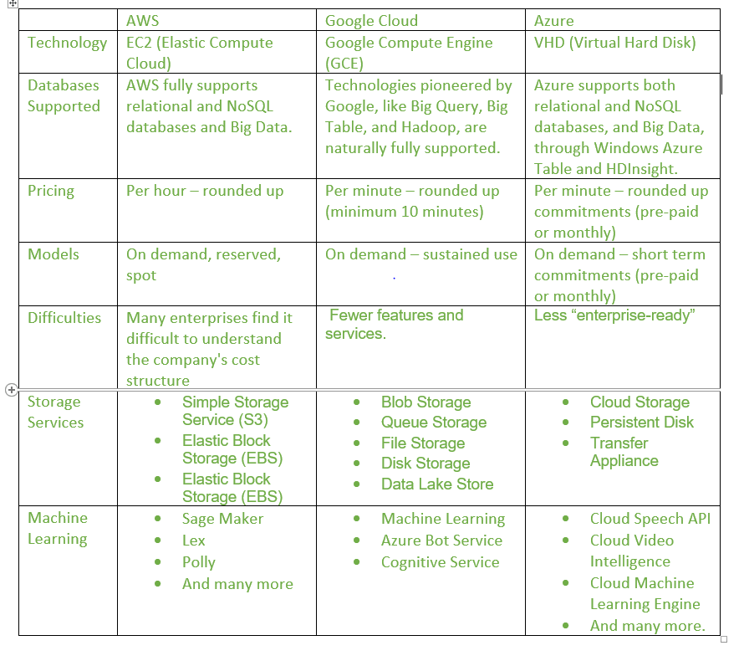

Salesforce Tutorial

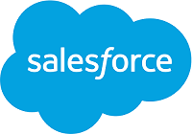

Salesforce is one of the best cloud-based CRM (Customer Relationship Management) platforms. It is an integrated CRM platform that provides a single shared view of each customer for all the departments within an organization, such as Marketing, Sales, Commerce, and Service.

What is Salesforce?

* Salesforce is a **SaaS or Software as a Service**, which means there is no need to install the software or server to work on. Users can simply sign-up in Salesforce.com and can start running the business instantly.  
  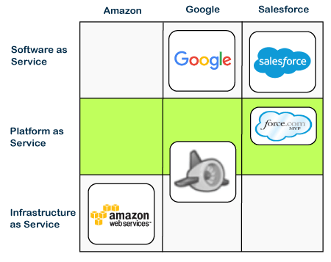
* It was founded by **Marc Benioff, Parker Harris, Dave Moellenhoff, and Frank Dominguez in 1999**.
* Salesforce was started as a CRM software, but today it provides various products and software solutions to users and developers.
* Since Salesforce is cloud-based software, hence it does not require any IT professional to set up anything.
* It provides one of the best ways to connect with customers, business partners, and clients over the single integrated environment. It allows the businesses to identify the customer's requirements, address the problems easily, and provide the same solution in the minimum timeframe.

Before going in deep , let's understand two basic concepts of Salesforce, **CRM and Cloud Computing**.

[CRM](https://www.javatpoint.com/salesforce-crm)

stands for **Customer Relationship Management**, a software to manage all the customer and company's interactions. It contains and manages all the customer-related information such as Customer Name, *Address, Phone Number, Email address, and other business-related information. The software keeps all the interactions done with customers, complaints registered by the customer, resolutions provided by the executive, and other customer activities with the particular business or product*.

It also allows us to track and manage the sales, marketing, and prospects given to customers.

Cloud-Computing

Cloud computing is a **technology to store, manage, process, and access the internet instead of a local server or computer hard drives**.

With the help of cloud computing, an organization can save lots of cost to local storage of data, maintenance of data, etc. The information over the Cloud can be accessed much efficiently and from anywhere, with the help of the internet.

Using cloud computing instead of traditional storage helps users with lots of benefits such as **speed, cost-effectiveness, security, global access, etc**.

## Why choose Salesforce?

In the above section, we have learned about the Salesforce, but why should we choose it? What are the benefits? So below are some points that explain the benefits of choosing Salesforce:

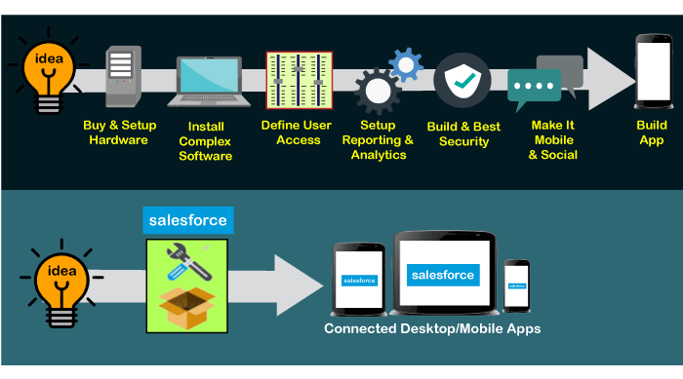

* The first benefit of choosing Salesforce is that we do not need to install any software to build an application or run our business activities. We can focus on building the apps instead of installing, setup, repairing, etc.
* Since it is the cloud-based CRM platform, any user can access it from anywhere using the internet.
* Any new user or business start-up can choose Salesforce for building apps or run business, as it is so affordable with lots of capabilities.
* One can easily integrate the Salesforce with any third-party applications, such as Gmail, which is much easier than other CRM Software.
* It is the world's number 1 CRM software, as it is easy to use, fast to deploy any app, and provide efficient outputs as per the requirements.
* The development cost is also very less.